SCHEMATIC / CIRCUIT DIAGRAMS
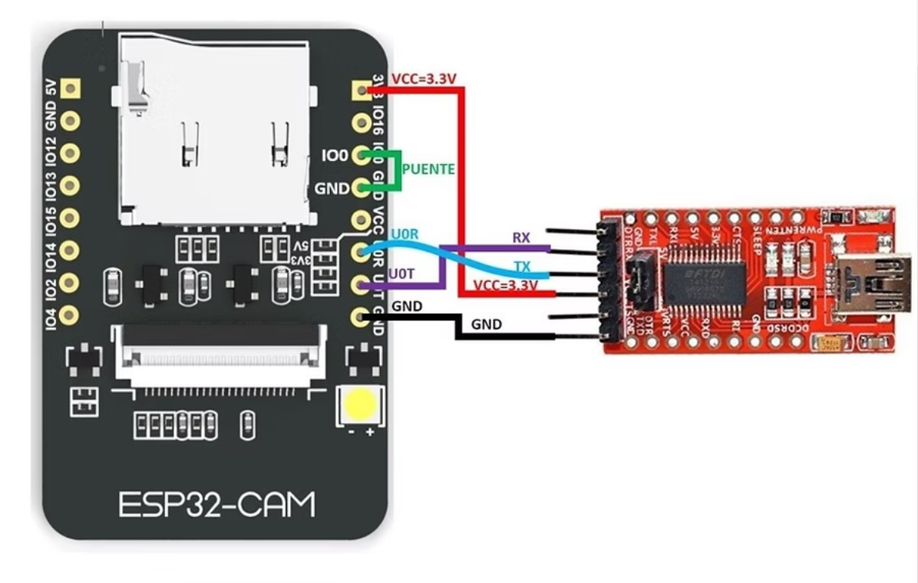
FIGURE 1. ESP32-CAM POWER AND PROGRAMMING CONNECTIONS
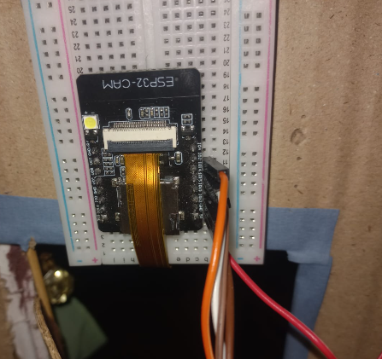
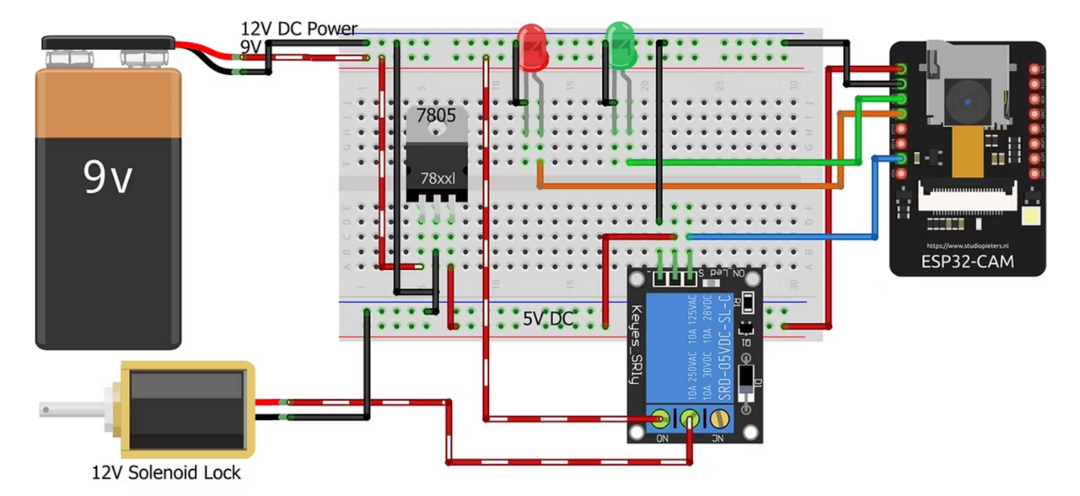
FIGURE 2. CYBER LOCK SYSTEM CONNECTIONS


